Year 2
ENGLISH:
Explore a range of texts using drama and role-play.
- The Incredible Book Eating Boy – to write a warning poster
- Goldilocks and The Three Bears – to write a letter of advice
- Beware of the Bears – to write a letter
- How to be a butterfly – to write a description
- To create a Harvest poem

MATHS: Place Value
- Reading and writing numbers in digits and words up to 100
- Making numbers with tens and ones
- Partitioning numbers up to 100
- Counting forwards and backwards in 1s and 10s
- Comparing and ordering numbers
- Count in 2s, 5s and 10s

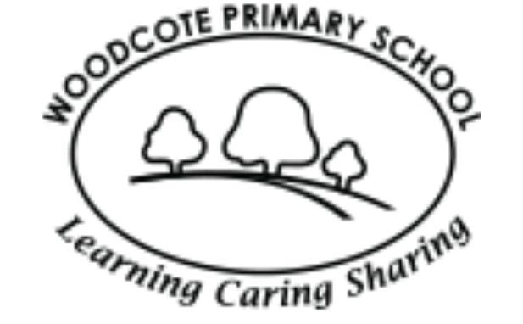
Curriculum Map
MUSIC: Performance singing

- Harvest Festival songs
- Nursery rhymes
- Singing songs with a pitch range.
- Understand dynamics and tempo.
COMPUTING: Internet Safety
- Being kind online
- My digital footprint
- How to stay safe online
Using the internet to research my local area

Autumn 1
PSHE: Me and My Relationships
- Why we have classroom rules
- Our ideal classroom
- Thinking about feelings
- Our feelings
- Bullying
- Don’t do that!

GEOGRAPHY: Wonderful Woodcote
- Use geographical vocabulary to refer to key physical and human features
- Exploring my local area
- Use aerial photographs to create my own map.
PE
- Fitness
- Team building
ART: Still life - Fruit
- Drawing fruit using pencil
- Sketching using charcoal
- Drawing in colour
- Creating a piece of art using pastels
- Painting fruit
- My final piece and evaluating my work

SCIENCE: Animals including Humans

- What do animals and humans need to survive?
- Sorting animals
- What are offspring?
- How do humans grow?
- Lifecycles
- My senses

Key Dates:
Stay and Learn: Tuesday 6th October 8.35am-9am- all families welcome into their child’s home class- Oak or Beech.
RE: Why do people celebrate important occasions?
- What important celebrations do I celebrate?
- Celebrating harvest
- The Sikh harvest festival of Vaisakhi

