Year 2
MATHS:
- Counting in 1s, 2s, 3s, 5s and 10s
- Find number bonds up to 10 and 100
- Adding and subtracting using a number line
- Adding and subtracting using real objects
- Adding and subtracting 10 to a number
- Solving problems involving addition and subtraction
- Finding totals of coins and notes
- Comparing amounts of money
- Finding change
ENGLISH:
- To read poems including a range of poetic features including onomatopoeia and rhyme.
- To write and perform a poem.
- To read a letter to Father Christmas and develop my comprehension skills.
- To write a letter to Father Christmas.
PE
- Invasion games
- Gymnastic
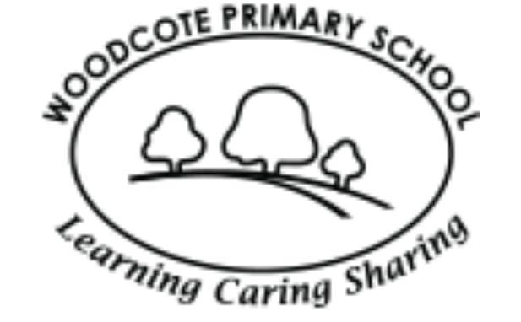
Curriculum Map
SCIENCE: Animals including Humans
- Which foods are healthy?
- What makes a balanced meal?
- Can I create a healthy snack?
- Investigating which exercise affects my heart rate the most?
- How to stay hygienic in the kitchen.
Autumn 2
DT: Designing a flying vehicle
- Designing a flying vehicle
- Making a flying vehicle
- Evaluating my design using design specification.
Art: Using printing techniques
- Finding out about inspirational print artists
- Creating our own printed art designs.

MUSIC: Performance singing
- Christmas performance
- Listening to music from different religions
- Learning and performing nursery rhymes

PSHE: Valuing Difference

What makes us who we are?

My special people

How do we make others feel?

When someone is feeling left out

An act of kindness

Solve the problem

COMPUTING:
- Internet Safety
- Coding
- Recording a performance with a group

HISTORY : Journeys- The History of Flight
- Use different sources to find out about the past
- Order dates on a timeline
- Recognise similarities and differences between past and present
- Recount significant events from the past
RE: Why do people celebrate important occasions?
- Sikh festival of Diwali
- The Christmas Story

