Sound | Image | Letter formation rhyme
Sss seahorse! |  | Over her head curl around.
A, a, apple! | 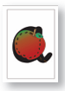 | Around the apple, up and down.
t, t, tree! | 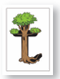 | Down the trunk, across the branch.
p, p, pony! | 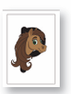 | Down her mane, up and around.
i, i, iguana! | 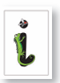 | Down the iguana, dot on the top.
nnn, needle! | 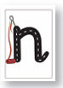 | Take the needle down and over.
mmm mushroom! | 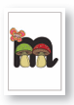 | Down the mushroom, jump over and over.
d, d, dinosaur! | 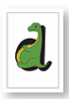 | Around the dinosaur’s body, up and down.
g, g, grape! | 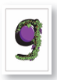 | Around the grape, down and curl.
o, o, octopus! |  | Around the octopus.
c, c, cat! | 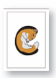 | Curl around the cat.
k, k koala! | 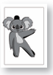 | Head to foot. Arm to toe.
e, e, elephant! |  | Along the elephants trunk, over and curl.
u, u, Umbrellabird! |  | Upside down umbrella, down and flick.
rrr, rocket! |  | Down the rocket, up and over.
h, h, hen. | 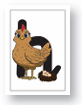 | Down to the feet and over the back.
b, b, bunny. | 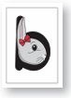 | Down her ears up to her bow around we go.
fff, fish. | 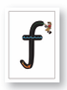 | Curve down the fishing rod, catch your fish.
lll, lolly. | 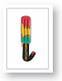 | Down the lolly.
j, j, jellyfish. | 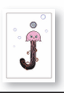 | Down the jellyfish and curl. Now we dot!
w, w, waves. |  | Down up, down up.
vvv, van. |  | Down, whizz up.
x, x, mix. | 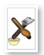 | Across the spoon. Down the sprinkles.
y, y, yacht. | 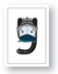 | Under the yacht, down and curl.
zzz, zigzag. |  | Zig-zag-zig.
qu, qu, queen! | 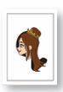 | Around the queen’s face, down and flick!

