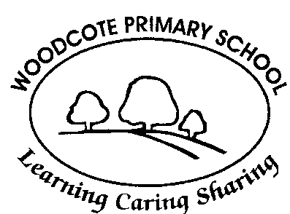

Oak class

Parent Information Booklet

Welcome to our school!


We are very much looking forward to meeting you and your child. We know that starting school is a very important and special time for all of you, and we thank you for choosing to send your child to Woodcote Primary School.
This booklet is intended for you to use as a reference during your child’s time in Oak class. We know that when parents and school staff all work together to support each child, they are best able to fulfil their potential and thrive, so we welcome the chance to work in partnership with you for the coming year.

We hope that the contents of this handbook will be of use to you in understanding life in your child’s first year at Woodcote, and we welcome every opportunity to speak with you about your child throughout their time with us.

Communication

To give your child the best start to school it is important that parents and staff work together to share their knowledge of the child. Staff are generally available for a brief word before or after school, or you can make an appointment to see the class teacher for further discussions. Please use the school office email if you are unable to catch us face to face. Young children are very perceptive, they can be unsettled by changes in routine, or by things happening at home. Please let us know if your child is upset or if you have a change in circumstances so that we can support your child’s emotional wellbeing.

The school year is divided into 6 short terms. Each short term the school website will be updated so you can see what knowledge and skills our learning will focus on. The website will also be regularly updated with photos which the children love to talk about with you. Each term, we aim to have one ‘Stay and Play’ or ‘Sharing Time’ where families are invited into class to share in our learning. We will vary on which day of the week these take place to try and ensure it gives all of you an opportunity to join in at some point over the year.

Please read the school’s weekly newsletter, sent to you on Parentmail each Friday, as this will inform you of what we have been doing that week so that you can talk to the children about their learning. It will also give you information about anything different that the children might need and any dates for the diary.

School Uniform

General expectations:
- We expect children to be neat and tidy.
- All items must be clearly named.
- Ensure footwear has velcro fastening or elastic laces, unless your child can confidently tie their own laces without help.
- Practise dressing and undressing independently before your child starts school. We find that jumpers, tights and coat zips prove particularly challenging, so these are especially helpful to practise until your child is confident. Show your child where their name is located on their belongings so that they can recognise what belongs to them.
- Hair, which is shoulder length or longer, should be tied up neatly, with any accessories plain and dark or navy blue.
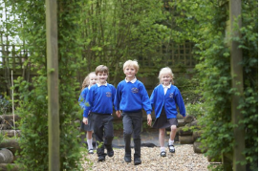
All year:

- Grey skirt or grey trousers
- White polo shirt with the school logo
- Sweatshirt or cardigan with the school logo
- Black school shoes. No trainers for daily wear.

Summer options:
- Grey shorts
- Blue/ white gingham summer dress, no culottes please.

PE Uniform

PE kits should come into school at the beginning of term and stay on pegs in the cloakroom. Every item in them and the bag itself, should be named. They can be taken home for washing at the end of each short term or earlier if required.
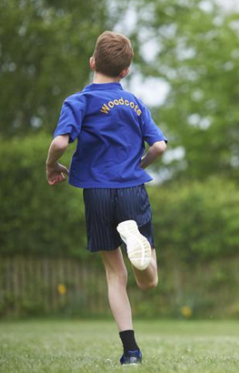
- Woodcote blue PE t-shirt with logo on front and back
- Navy blue shorts
- Dark blue or black tracksuit bottoms (plain and without logo)
- Trainers with velcro fastening or elastic laces.
- Plimsolls are not required unless your child has a medical need which prevents them from doing indoor PE barefoot.
- A PE bag to hang on their peg, with plenty of room to store clothes and trainers in.

Financial Support for Purchasing Uniform

We know that purchasing uniform can put a strain on family finances. For this reason, we offer a free uniform each year for children who qualify for Pupil Premium funding. There is a Pupil Premium form to apply for this in your pack and we encourage families to return this form, as many families do not realise, they are eligible until they apply. If you are eligible, the school will receive extra funding which is used to further support your child’s learning.

Outdoor Clothing

Outdoor learning is highly valued in the Foundation Stage curriculum.

Children will spend time outside every day, please keep a pair of wellies in school for outdoor learning. They also need a puddle suit to protect their uniform when playing in the mud kitchen and other sensory areas.

Coats are needed throughout the year. Even in the warmer months, a light, waterproof coat should be brought in or kept in school every day.


Hats should be worn into school on sunny days and all-day sun cream should be applied at home in the morning. We are unable to apply sun cream to children.

Punctuality


The school gates open at 8.35am and you can head straight to the classroom gates. A member of the team will meet you at the classroom gate and then the children can walk into class. We begin each day with fine motor activities (to strengthen their hand and finger muscles) so please ensure your child comes to school on time. The register is taken at 8.45am.

Children should be collected promptly at 3.15pm. It can be very distressing for a child to be collected after their friends, so please make every effort to be on time.

Children are only allowed to leave with a pre-agreed adult. Please use the form in your pack to let us know who can collect your child. If you need to make alternative arrangements for the collection of your child at short notice, please ring the school office who will pass a message through to class. If someone else tries to collect your child, without notice from you, we will call you to check.

Lunch

ABM catering solutions provide our school dinners. A variety of meals including hot and cold options can be ordered online via Parentmail and information has been provided in your packs for setting this up. Children in the first three years of school (up to the end of Year 2) are entitled to a meal free of charge every day. It is advisable that you choose the menu with your child so that they are familiar with the meals you have chosen and know what to expect each day. If you need any further information, please check the school website or speak to the school office.

School hot lunches are eaten at Langtree. The children are taken over to Langtree by a member of the class team and return to school with a lunchtime carer. Home packed lunches and school provided cold lunches are eaten in our school hall. We encourage a healthy balanced-diet and packed lunches should not contain fizzy drinks, sweets, or chocolate. We are a nut-free school, no nuts or products containing nuts (e.g. Nutella or hazelnut spread) are allowed into school. Please make sure packed lunch boxes are clearly named.

Snacks

Please bring in a named water bottle for your child every day. This bottle must only contain water as this is the healthiest option for your child’s body. We know some children say they do not like water, but we will work on this with them and ensure they do not become dehydrated.

As part of the National Fruit Scheme, we receive seasonal fruits and vegetables for the children including carrots, peas, tomatoes, apples, oranges, bananas and pears. Children are also offered a cup of milk during the school day. If your child would like to bring in their own fruit or vegetable snack from home, they are welcome to. These can be placed in their drawer until snack time.

Book Bags
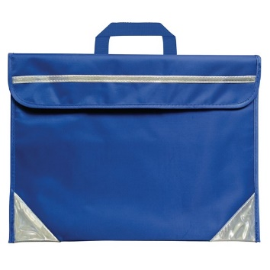
Every child will need a book bag to bring into school daily. Book bags live in the children’s drawers so a small, neat bag (such as the Woodcote one) is essential. The children’s reading diaries and reading books should be kept in their bookbags every day. Please make sure you empty other items out of their book bags regularly.

Medication

In line with the school’s Health and Safety policy, children can only be given medicine at school if it is in the original packaging. If it is a prescribed medicine, it must have a pharmacy dispensing label which shows your child’s name and dosing instructions. Children with asthma and who require a reliever inhaler must keep an inhaler at school and provide an asthma care plan verified by their surgery. Medicines will be stored appropriately during the day and used as instructed. A medical consent form must be completed for all medicine to be used at school (available from the office).

Please let school know if your child has any medical needs that affect their daily life, such as allergies or long-term chronic conditions by completing the relevant paperwork found in your enrolment pack.

Illness

If your child is ill, please contact the school office before 9.30am each day that they are off school. If your child has had diarrhoea or been vomiting in the last 24 hours, please keep them off for 48 hours after the final episode of sickness or diarrhoea as these types of bugs spread easily around the school community. Encourage hand washing regularly to reduce the spread of germs. This NHS video / song can be a fun and helpful way to teach effective hand washing. How to wash your hands NHS song | NHS - YouTube
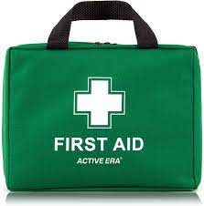
There are qualified first aiders in the school. If your child has an accident during the day requiring first aid, we will treat the injury, write the incident down and inform you at the end of the day. If there is a more serious incident, we will contact you during the school day. Please make sure that we hold up-to-date contact details. Minor bumps and scrapes which do not require first aid are not recorded or reported formally.

Jewellery

For health and safety reasons children are only allowed to wear earrings that are studs/ sleepers. No other jewellery may be worn. Earrings must be removed or taped over during PE lessons. We also ask that Reception children do not wear watches to school.

Birthdays

Your child is invited to wear home clothes on their birthday and to bring in a book to share for story time (if their birthday falls on a weekend or holiday they can wear their home clothes on the nearest school day). Some parents choose to send in a small treat for the class to share and if you do, please note it must not contain nuts.

Due to GDPR, we are unable to provide class lists for party invitations, but we are happy to place invitations in book bags on your behalf.

The Early Years Foundation Stage (EYFS)

Curriculum

The EYFS framework sets out the statutory standards for the development, learning and care of children from birth to age 5. It promotes teaching and learning which gives children the broad range of knowledge and skills that provide the right foundation for good future progress through school and life.

The curriculum is divided into Prime and Specific areas.

Three Prime areas, which underpin and support children’s learning in all other areas:
- Communication and Language
- Physical Development
- Personal, Social and Emotional Development.

Four Specific areas, that include developing specific skills and knowledge:
- Literacy
- Mathematics
- Understanding the World
- Expressive Arts and Design

The Characteristics of Effective Learning describe the behaviours children need to show and develop in order to learn:
- playing and exploring - children investigate and experience things, and ‘have a go’
- active learning - children concentrate and keep on trying if they encounter difficulties, and enjoy their achievements
- creating and thinking critically - children have and develop their own ideas, make links between ideas, and develop strategies for doing things

During your child’s time in the Foundation Stage, we plan and provide a rich and varied range of structured play activities to enable all children to progress across the areas of learning and develop their characteristics of effective learning.

Supporting your child at home – TALK, PLAY, MOVE, READ

Talk | Name their feelings & explain why they are feeling them e.g I feel sad because I hurt my knee.
Talk | Talk about your days – what made you happy / sad / angry / made you laugh?
Talk | Take turns in conversation, practicing responding to what the other person is saying.
Talk | Descriptive commentary- describe what you are doing as you do it e.g as you butter a slice of toast- I am scraping a thin layer of butter from the tub and then scraping it across the top of the toast.
Talk | Singing nursery rhymes and songs.
Play | Join your child in their choice of play – sit with them and take their lead. Play alongside, describing what you are doing rather than questioning them as this is often more effective in allowing the play to flow.
Play | Be imaginative with them and have fun!
Play | Bring maths into your play – counting what you have, noticing what shapes you are using, sharing, comparing number and size, measuring.
Move | Cooking – peeling, chopping, grating, stirring
Move | Draw pictures together.
Move | Play hide and seek / chase
Move | Go to the park and travel along the monkey bars, learn to swing by themselves.
Move | Go the woods and climb trees, cycle, swim.
Move | Throwing and kicking different sized balls, counting as you catch / score.
Move | Count as you jump, skip, climb stairs.
Read | Reading (as mentioned in the homework section)
Read | Share books together every day- we send home a weekly sharing book, but the library also offers a great service which is free! Re-read books so your child can explore them- the feelings of characters and their choices and embed stories in their memory to use in their own play and writing.
Read | Notice sounds / letters and write in the real world around them.
Read | Sound Scavenger Hunt- e.g go and find 3 objects which begin with ‘a’.

Homework
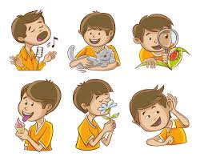
Children often find the first year of school incredibly tiring, even if they have been used to attending a previous setting full time. For this reason, we do not set any formal homework other than reading.

Reading with your child each day is essential in supporting your child to embed the phonics knowledge they are learning and to put this knowledge and their ever developing skills of segmenting and blending into action.

Once the children have enough phonics knowledge and can segment and blend to read, a phonics book which links to the sounds and high frequency words they have been learning, will be sent home each week.

Please re-read this book over the week it is with you, as this is important for your child to develop reading comprehension (understanding), and increased independence. On the second and third reads we would expect that your child could spot the repeated pattern of the text and segment (sound out) and blend words to read.

Your child will be given a reading diary so that you can sign when you have read with them. If diaries are unsigned, we will assume the books have not been read.

Reading diaries and reading books will usually be collected in every Monday at drop off and we aim to change them and send them back to you the same day.

The newsletter may contain suggestions of activities you can do at home to continue the learning from school and over the holidays.

Assessments
We regularly monitor and assess your child’s progress, both informally and formally. These assessments allow us to quickly recognise any strengths or needs your child may have and plan activities to support their learning.
If your child is needing extra support to ‘keep up’ in phonics, we will do short interventions in school with them and send the same learning home.
We highly value your opinion regarding your child’s development as the year progresses.

If we feel that your child may have a Special Educational Need we will speak with you about the most suitable course of action, which may include liaison with external agencies such as Speech and Language Therapists.

We love celebrating every child’s proud moments! Each child has their own space on our display board in the classroom and you are welcome to send in a note, certificate, or photograph to record significant achievements such as swimming badges, riding a bike without stabilisers, taking part in a dance show, or achieving something for the first time after lots of practice. We are happy to make photocopies of certificates or photographs and return the originals to you.

In the final term of the year, every child is assessed against the Early Learning Goals (ELG’s), in line with statutory requirements. These judgments are made based on the professional knowledge of the staff who work with your child, and classroom observations. The assessment considers what your child knows, understands, and can do. The main purpose of the assessment is to support a successful transition to Key Stage 1, so that the Year 1 team are informed about every child’s stage of development / learning needs to help them plan a curriculum which meets their needs. Their assessment against the Early Learning Goals will be given to you as part of the end of year school report and will record if they have meet their ELG’s in all the Prime Areas and the Specific Areas of Literacy and Maths. If the ELG’s have been achieved, then they are said to have reached a ‘Good Level of Development’ (GLD). If they do not meet these ELG’s, this does not mean they have not made good progress but that they still need to develop in these areas before being ready for all of the Year 1 curriculum.

Parents Evenings
In the Autumn and Spring terms you will be given the opportunity to attend Parents Evening to discuss your child’s progress. In the Autumn term we discuss how they have settled into school and begun building healthy relationships. In the Spring term, we will let you know of their progress and share next steps which will help your child to continue their learning journey. Of course, if you have any questions or concerns in between these consultations, please do not wait, instead speak to us at drop off or pick up and, if needs be, we can arrange a meeting.

Structure of our day

Our day evolves through the year, as the children settle and grow but a typical day will look something like this..

Morning
- Being welcomed by a member of the team
- A fine motor activity to build hand and finger strength.
- Phonics
- Snack Time
- Movement Break
- Maths Mastery
- Play and Learn Time
- Tidying up Time
- Singing – focus on nursery rhymes / poems and songs of the term
- Getting ready for lunch time including going to the toilet and washing hands.

Afternoon
- Taking the afternoon register – focus on feelings.
- Carpet input – based on topics we are learning about, music and PSHE
- Play and Learn Time
- Tidying Time
- Story Time
- Getting ready for home
- Goodbye Song and Numberblocks
- Home time

We promote respect for the classroom and its resources. All children will be expected to help tidy up and look after the learning environment. We also promote independence, so your child is responsible for putting away and collecting their own belongings each day.


We are looking forward to fun, happy and successful year ahead!

