Year 2
ENGLISH: Narrative
Jack and the Beanstalk
- Retell the story using drama and role-play
- Write a character description
- Write a setting description
- Grammar – to use full stops, capital letters, finger spaces, interesting adjective and nouns.
- Write a harvest poem
- To use my phonics to read and spell new words

MATHS: Place Value, Shape and Money
- Counting in 1s to 100
- Counting in 10s to 100
- Partition numbers up to 100
- Count in 2s, 5s and 10s
- Solving problems involving number
- Recognise and describe 2D and 3D shapes
- Identify lines of symmetry
- Find totals with money

PE
- Throwing and catching
- Gymnastic
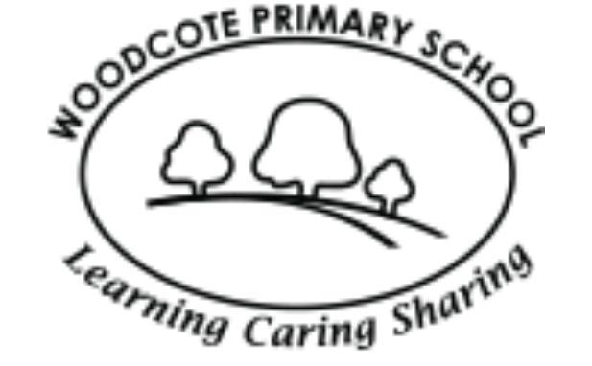
Curriculum Map
MUSIC: Performance singing
- Harvest Festival
- Christmas performance
COMPUTING: Internet Safety
- Being kind online
- My digital footprint
- How to stay safe online
Using the internet to research about the history of flight

RE: Why do people celebrate important occasions?
- Celebrating harvest
- The Sikh harvest festival of Vaisakhi

PSHE: Me and My Relationships
- Our ideal classroom
- How are you feeling today?
- How can we help others to feel happy?
- Being a good friend
- Bullying

ART: Still life - Fruit
- Drawing fruit using pencil
- Sketching using charcoal
- Drawing in colour
- Creating a piece of art using pastels
- Painting fruit
- My final piece and evaluating my work

GEOGRAPHY: Journeys
- Use geographical vocabulary to refer to key physical and human features
- Name, locate and identify characteristics of the four countries and capitals of the UK
- Use aerial photographs and plans
SCIENCE: Animals including Humans
- What do animals and humans need to survive?
- What are offspring
- How do humans grow?
- Life cycle of a butterfly
- Life cycle of a chick

Autumn 1

