Day due back: Tuesday 28th January
Hornbeam Homework Feedback Sheet

Please ensure that a sensible amount of time is spent on homework and that it does not become overly burdensome to you or your child, approximately 15 - 20 minutes should be sufficient. If the task is not completed in this time do not feel obliged to struggle on (although I appreciate that some children who are enjoying the task may wish to continue to completion). Thank you for the feedback that you give and do please continue to let me know how the homework goes and certainly if there is any issue with it.

My child worked independently on this work

My child did this work with help
Objective/Notes to parents

This week we have been taking inspiration from the book ‘OI FROG’. The children absolutely adore the book and have really enjoyed looking at the rhymes.

One thing we also have noticed is that the frog uses the plural forms of all nouns. Instead of cat they say cats – implying that all cats are being referred to. We have focussed on the spelling rule ‘adding the suffix -s or ‘es’.

Homework:
Can you turn all the singular forms of the nouns into the plural forms by adding either an ‘s’ or an ‘es’. For a superstar challenge can you write a sentence using one of the words. For example, Hares sit on chairs. 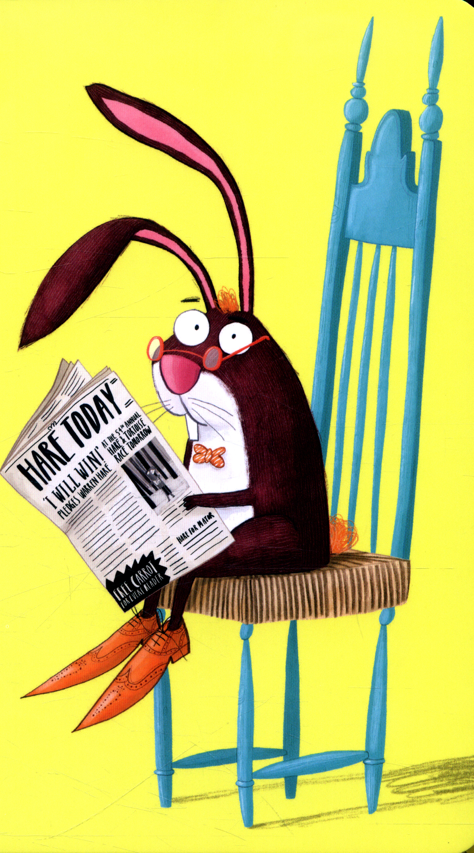

Parent’s/child’s Comment

