Read  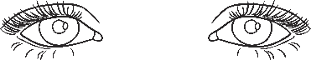  and Say | Read, Say  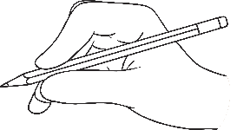  and Write | Listen and  Write
tie
pie
field
thief
high
night
going
take
told
over

